**Text Mining**

**Extracting Reviews From Trip Advisor**

**Word Cloud**

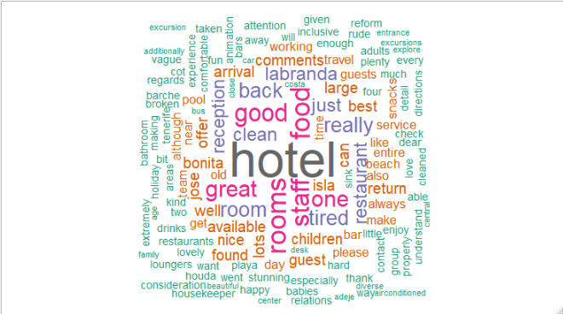

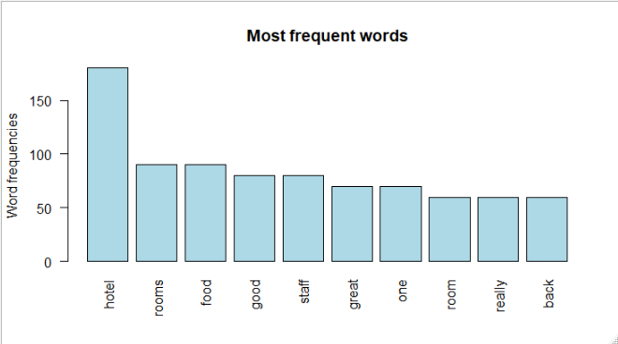

**From the above information we can say that Hotel Labranda Isla Bonita is having good rooms with good food as well.**